**ACCELERATION MODEL**

# Hypothesis

* Non-deformable tyres
* No slip of tyres
* No suspensions
* No loss in transmission
* The support and aerodynamic drag are considered
* No transitional regime considered

# Complementary information

* The mechanical equation was obtained with a theorem of kinetic energy on the whole vehicle.
* Choice for the coefficient of friction:
  + Constant
  + Value corresponding to 11% slip for 13 inches and 12.5% for 10 inches (maximal friction)
* Engine curve taken from a previous vehicle

# Main issue

# 

Figure 1: Comparison of acceleration event time simulation for 10-inch and

13-inch wheels

Figure 1: 2D model for A-Arms geometry early design

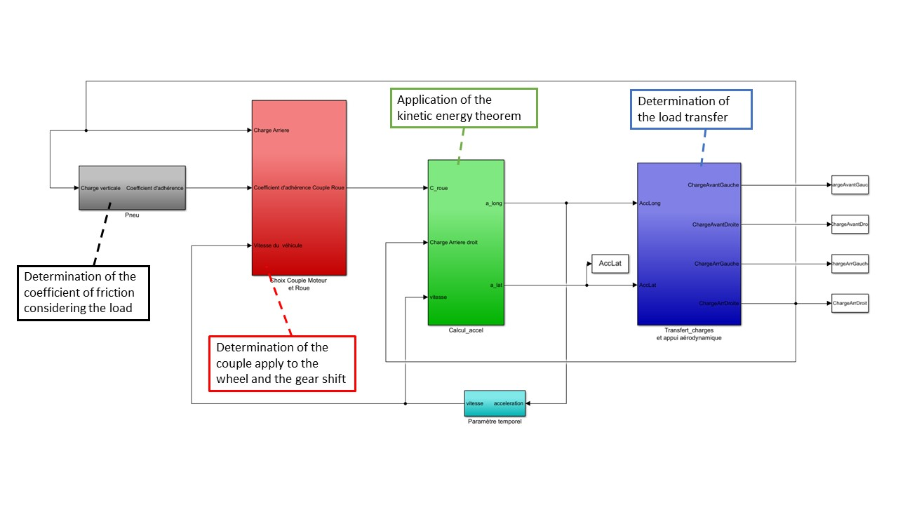

Figure 2: Simulink presentation of the acceleration model